Name –Prajwal Singh

En.No.- 161B144

Batch –B-5

***Python Project***

***Mining Department Database***

***Subject :-*** This project is on Mining Depatment Database in this we can see description about different type of mines and their mining process and we can also feed different data and information about employees and machinery of differnt mines.

***Description of code of lines, syntax and datbase***

When we will run the project, first of all the front page will appear where the information abot the programmer is given. i.e.

Progrmmer Name ,En No., Batch, Email, Mobile no. and the guider name.

At last their is a “button” by clicking which the current page will get destroyed and a new profile page will appear.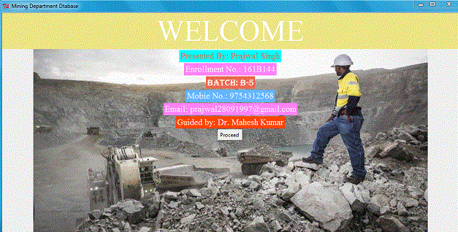

**Errors while making this page:-** I was trying to include “splash screen” but every time an Tkinter exception (error) was occuring. That’s why I have included “Proceed Button” so that we can open next page by clicking on it.

***Login Page:-***  In this page a user can create a new account and then , he can easily sign in by entering his/her usename and paasword .

***Terms Used***:- At first for signing up a user has to enter his/her “Username , First name , Last name and Password”. After that a message box will appear conforming that you are new user and then you can Log in by entering your “Username , Password” and after that click on the Log in button.(Note:- If the account is already created then on clicking sign up button an error message will get displayed. As well as if no account is created then after clicking the log in button a message will appear regarding no account is created.)

By logging in you will enter into the Mining Department Database.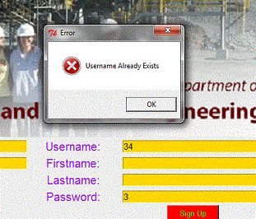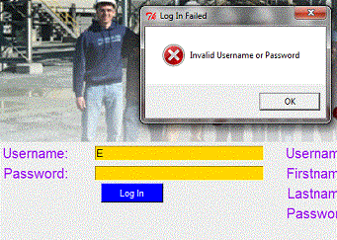

***Making :-*** Here, I have included database by which a user can create his/her account and then at any time it doesn’t matter how many times he/she closes the window his account will remain there.

I have also included an image by using the image syntax.

Errors:- At first i was getting an error related to display of image as I was declaring the wrong function in its command , but later on I solved it.

If you will click on the sign up button without filling any entry then also your account will be created. (I am trying to still trying to solve this error) .

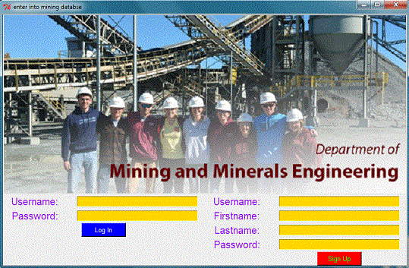

After Logging in the current page will be destroyed, and a new page will appear.

***Third Page :-*** In this page we will get introduced to Different type of coal mining methods.

I have created five Check buttons, and if we choose any one of them and click on See Details button a message box containing information about that type of mining will appear.

If we will click on proceed button then a new Tkinter box will appear and the current page will get destroyed.

***Making :-*** In this page the button named “See Details is linked to every radio button (by declaring the variable in a different function and using if else condition). As well as same process is used for Proceed Button (Different mining functions are called).

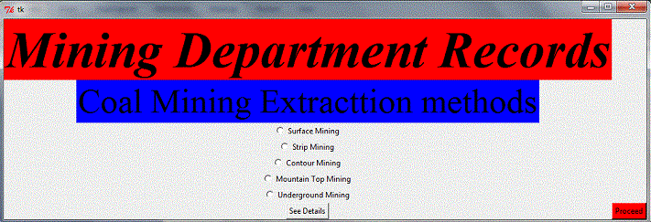

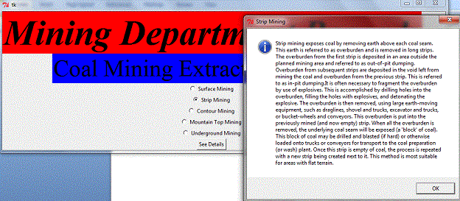

## ERRORS:- At first when I was clicking on the button then every radiobutton is showing a single information but after declaring different variables and using (Toplevel) the error is gone, It is same with the appearance of new Tkinter box solved using Toplevel.

***Fourth Page :-***  In this page you have to choose between two options that is “Machinery and Employees”.

When you will click on show button then a new page will appear containing the database about that radio button.

When we will click on back button previous page will appear.

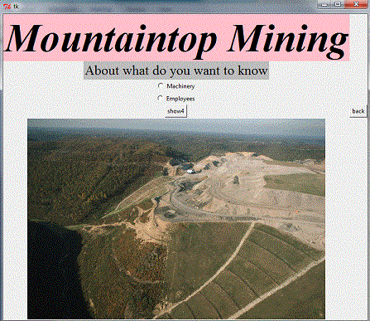

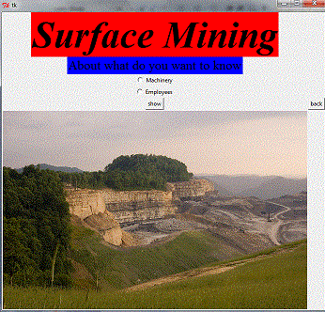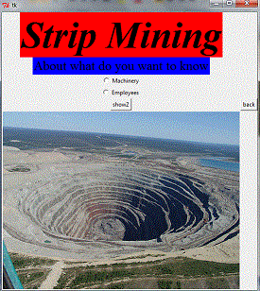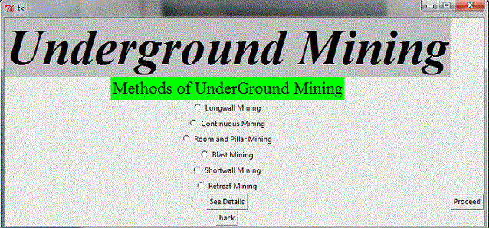

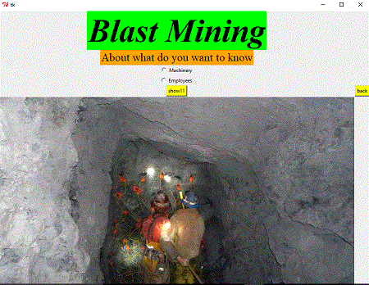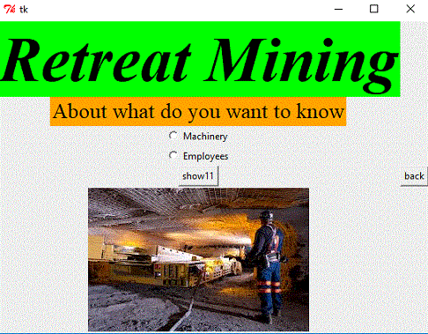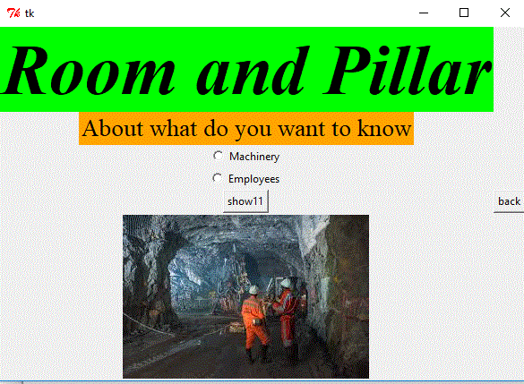

s.

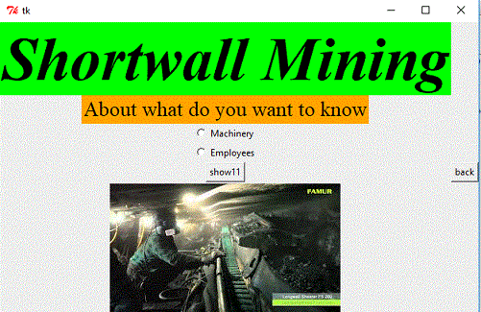

***Fifth Page:-*** Now the database regarding to “Employees or Machinery “ will appear where you can fill following entry which will get register in your database, and by clicking show all you can see the entire entry done by you.

# Error:- At first radio button values are showing null but after applying Toplevel it got corrected.

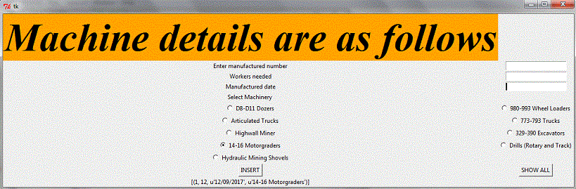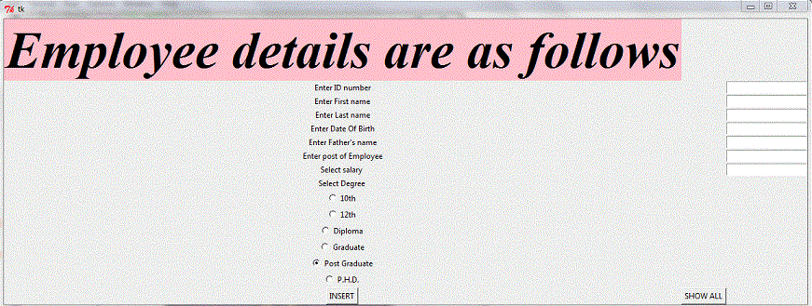

## The End